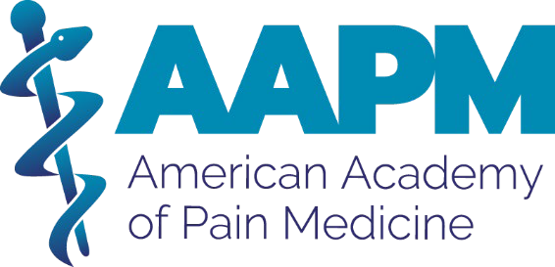

Board of Directors Nomination Form

AAPM Board of Directors Nomination Timeline and Process:

AAPM Board of Directors & Nominating Committee Timeline & Process:
10.12.26: Nominations Open
11.04.26: Nominations Close at 11:59 pm Eastern
11.06.26: Nominee vetting and interviews
11.17.26: Nominee vetting and interviews conclude
11.23.26: Slate announced
11.27.26: Additional nominations by petition due
12.01.26: Elections Open
01.03.27: Elections Close at 11:59 pm Eastern
01.18.27: Results announced
03.21.27: Newly elected leaders take office

All newly elected board members must attend the Board Orientation and Board Meeting at PainConnect 2027, AAPM’s Annual Meeting, on March 21, 2027, in Orlando, FL. PainConnect 2027 will take place from March 18 to 21, 2027. The Board of Directors meets at least four times annually, and all meetings are mandatory. Meetings not held at PainConnect are conducted via Zoom and have typically been held on Wednesday evenings from 7:00 pm to 9:00 pm Eastern Time.
Note: Those serving on the Nominating Committee will be ineligible for the Board of Directors ballot while serving on the AAPM Nominating Committee.

INSTRUCTIONS: Please complete the form and upload your professional headshot and CV.

2027 Election Open Positions:
Secretary (1) – two year term
Director-at-Large (1) – initial three-year term as part of our transition
Doctoral-Level (non-physician) Director (1) - initial three-year term as part of our transition
Nominating Committee (2) – two-year term

- Nominee Identification
Photo: Attach a high-resolution photo. This photo will be used in all nominations and election communication.

Bio: Please type in a brief bio (150 – 300 words). Your bio will be used in all nominations and election communication.

First Name, Last Name
Credentials
Street Address
City
State Zip
Work phone | Mobile Phone
Email Address
Specialty:
How long have you been a member of AAPM? ____years
Current Volunteer Position with AAPM
How long have you held your current volunteer position? ____years
What is your total experience in the field of pain medicine? _____years

II. Employment & Practice Information
Type of Organization: __ Private Practice ___Academic ___Academic Research __Community Health ___Federal ___Hospital-Based

Organization:
Your Title:
Street Address, City, State, Zip
- What is the focus of your Pain Medicine practice? (dropdown, multiple choice)
  - Addiction Medicine
  - Behavioral Pain Medicine
  - Cancer & Palliative Pain
  - Chronic Pain Management
  - Comprehensive Pain Medicine
  - Headache & Orofacial Pain
  - Interventional Pain Medicine
  - Pediatric Pain
  - Pelvic Pain
  - Regional Anesthesia/Acute Pain
  - Restorative Medicine
Percentage of time spent practicing pain medicine:
- What is your Specialty of Origin?
Anesthesiology
Dentistry/Oral Medicine (doctoral non-physician director)
Emergency Medicine
Family Medicine
Gastroenterology
Geriatrics
Internal Medicine
Neurology
Oncology
Orthopedic Surgery
Pediatrics
Pharmacy (doctoral, non-physician director)
Physical Medicine & Rehabilitation (PM&R)
Psychiatry
- Please specify percentage of time practicing in your specialty of origine:
Employment Experience: Please provide a 30- to 50-word summary of your work experience. If you are retired, please describe the work that you did during the time you were employed.

III. AAPM Strategy
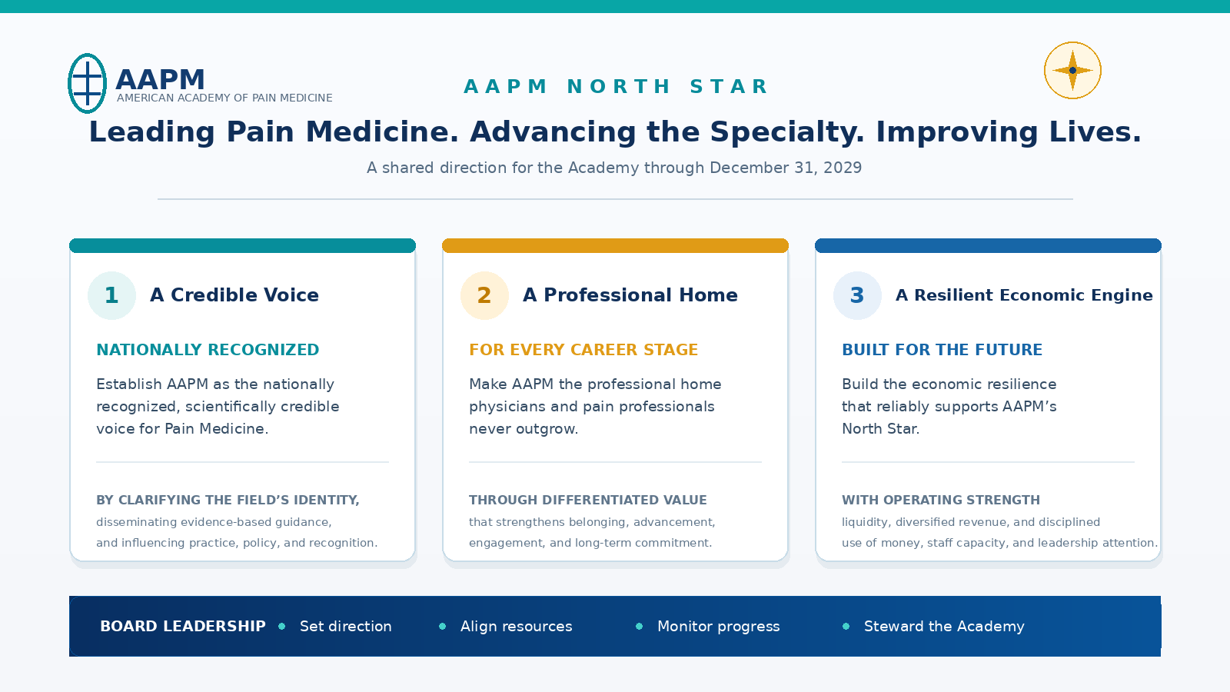

Strategic Pillar One: A Credible Voice
By December 31, 2029, establish AAPM as the nationally recognized, scientifically credible voice for Pain Medicine by clarifying the field’s professional identity, setting and disseminating evidence-based guidelines, and translating multidisciplinary expertise into influence on practice, policy, and professional recognition.

Strategic Pillar Two: A Professional Home
By December 31, 2029, make AAPM the professional home physicians and pain professionals never outgrow by delivering differentiated career value at every stage that strengthens belonging, advancement, engagement, and long-term commitment to the specialty.

Strategic Pillar Three: A Resilient Economic Engine
December 31, 2029, build a resilient economic engine that reliably funds AAPM's North Star through recurring operating strength, adequate liquidity and reserves, diversified net revenue, and disciplined allocation of money, staff capacity, and leadership attention.

- The Academy leadership developed its three pillars to be focused and flexible. The intent is that all activity will drive our mission and shape what the Academy looks like in three years. Based on the information above, your professional experience, and your experience with AAPM, what suggestions would you make to move the Academy forward? (500 words)

- What is your professional vision for the Future of Pain Medicine?

- Why would you like to serve on the AAPM Board of Directors? (limit 50 words)

IV. Qualifications

- How has AAPM membership brought value to your career?

- After reviewing the AAPM Strategic Plan, what abilities and attributes will you bring to the board’s strategic deliberations?
- Describe one transformational/defining experience in your professional life you have been involved with and what you learned from that experience.
- List significant leadership commitment and involvement within the field of Pain Medicine.
Organization Name Organization Type Leadership Position Duration of Appointment
- Is there anything else you would like the nominating committee to know about you that has yet to be stated?

Signature: I hereby give permission to the Nominating Committee to contact me, print my Candidate Profile and Statement, and consider me for nomination to the AAPM Board of Directors on the official AAPM 2027 Election Ballot. By signing, I confirm that I have read the board expectations and duties on the call for nominations page on painmed.org.

Signature

