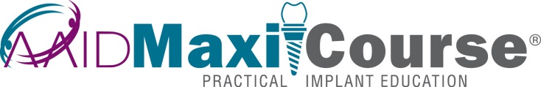

Sponsor Logo

(*Date*)

Dr. (*Name*) has completed the AAID MaxiCourse® in implant dentistry cosponsored by the (*Name of Sponsoring Institution*) and the American Academy of Implant Dentistry.

This MaxiCourse® provided 300 or more hours of continuing dental education specifically related to implant dentistry. This letter is verification of participation of the above-named MaxiCourse® attendee.

(*Name, credentials*)

(*Name*)MaxiCourse® Director